**Our objective**

We help you to express your personality and brand in a cool way.

We supply useful letter-themed accessories such as pendants, key chains, golf pin, etc. to consumers who want to express themselves in an impressive and unique way, and businesses who want to improve their brand awareness.

Unlike other shapes, letters are associated with unique meaning and sound. Letter-themed accessories let you give your friends and even yourself your clearer impression and message.

We have been developing the know-how and the skill to turn letters including kanji into cool accessories.

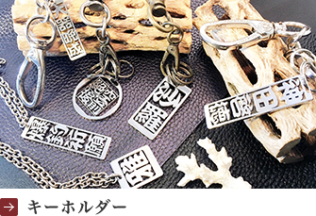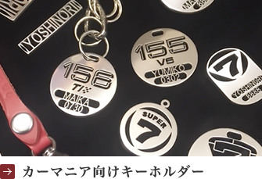

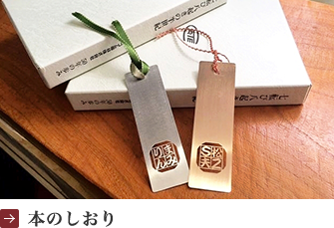 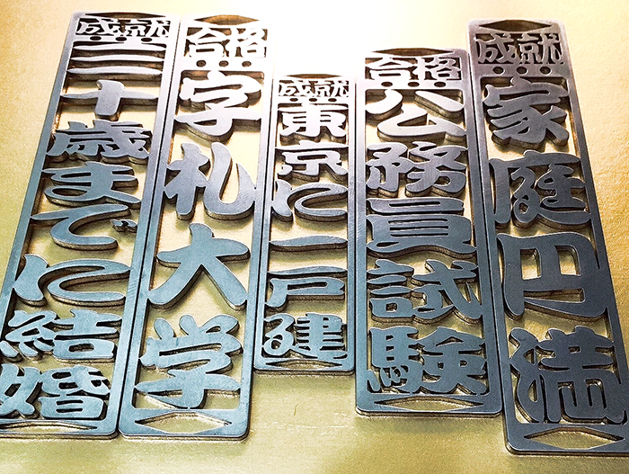

|  |  |
| --- | --- |
| **Company Name** | **Senjyu Corporation** |
| **Office** | **Inaridai 18-11, Itabashi-ku, Tokyo 173-0002** |
| **Shop** | **Azanafuda Honpo**  **Kami-Jyujyo 3-25-1, Kita-ku, Tokyo 114-0034, Japan** |
| **TEL** | **03-5939-6097** |
| **FAX** | **03-5939-6017** |
| **E-Mail** | **info@azanafuda.com** |
| **Founded** | **February 2016** |
| **President** | **Yoshinori Koizumi** |
| **Core Business** | **Design, manufacturing, and sales of fashionable accessories on theme of letters** |

**(注) 以下の部分、About usに加えてください。同時にトップページの写真スクロールに紛れ込ませてくれませんか？クリックしたら八泉のランディンスページを開く感じで。**

**Hachisen**

Get kanji name and bring in happiness!

We offer you several combinations of kanji representing the sound of your first name. Each kanji name offered has its unique fortune and meaning. Just choose one of them and enjoy your kanji name!

**This is free service.**

ボタン：Get Free Kanji Name Now